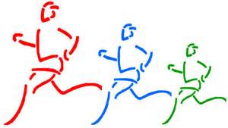
Set the Pace with Presleigh
5K Color Run/Walk
In November of 2014, Presleigh Lefers a six year old Kindergarten student at Corsica Elementary, was diagnosed with Type 1 Diabetes. Type 1 does not discriminate, is not always genetic, and can strike anyone. Help us find a cure for this life altering disease. A cure can be found in the near future with everyone’s support.
Corsica High School /Saturday, April 18, 2015 /9:30 A.M.
$25.00 participation fee/donation per participant
Please make checks payable to: Micah Noteboom (for the benefit of Juvenile Diabetes and the Lefers family) Race forms available at Corsica Home Page or Corsica High School Home Page.
------------------------------------------------------------------------------------
Name: _____________________________
Adult T-shirt size: Small / Medium / Large / Extra Large
Please return your registration and payment on or before April 9th to:
Micah Noteboom - P.O Box 41- Corsica, SD - 57328
(605) 946-5360 Thank you for your support

